

UCAS Personal Statement Process
Name:________________________
Tutor Group:___________________

Oxbridge/medical/dental/veterinary school deadline for submission of completed UCAS form is 21st September
All other UCAS forms- deadline for submission of completed UCAS form is immediately after October Half Term

Draft Deadline:__________ Signed (tutor):______________

Finish Date:_____________ Signed (tutor):______________

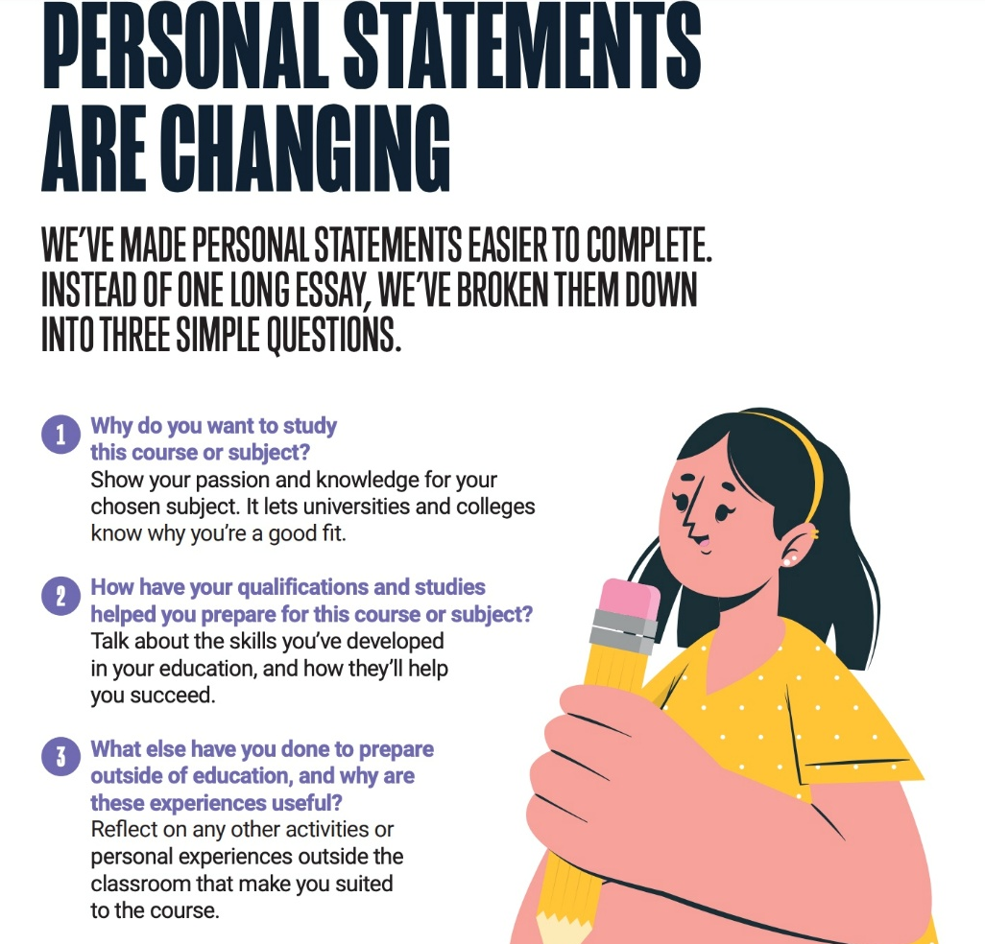

The new personal statement questions

Question 1: Why do you want to study this course or subject?
This is your opportunity to showcase your passion and knowledge of your chosen subject area and to demonstrate to universities and colleges why it’s a good fit for you and your future ambitions.
Examples of what you might talk about here are:
- Your motivations for studying this course(s)
Have you been inspired by a key role model or moment in your life? Maybe it’s a subject you love and want to pursue further. We’re all driven by something and it’s important to talk about how yours has led you to this course or subject area.
- Your knowledge of this subject area and interests
Perhaps there’s a particular subject area you’ve researched and can’t wait to learn more about. A book or subject expert doing great things that have sparked your interest? Universities and colleges want to see you have done your research so they can be confident this is something you will enjoy and excel in. This is a great place to highlight super-curricular activities as evidence of curiosity and interest in the subject outside of the classroom.
- Your future plans and why this is a good fit for you
If you already have a particular profession in mind you could talk about how you’ll use this to launch your career. If you don’t, think about what’s important to you and your future, and how the knowledge gained from your chosen course(s) will help you achieve this.
Question 2: How have your qualifications and studies helped you to prepare for this course or subject?
This is your chance to shout about the relevant or transferable skills you’ve gained from your formal education and highlight your understanding of how they will help you succeed in this subject area.
Examples of what you might talk about here are:
- How your studies or training relate to your chosen course(s) or subject area
This could be current or previous studies within a school, college, training provider, or even a short online university course – any form of formal education. The main thing here is to focus on what’s most recent and relevant to your chosen course(s). If you are no longer in full-time education, use section three to talk about your experiences since leaving.
- What relevant or transferable skills you have that make you a great candidate
Maybe there are a couple of subjects that have helped you develop a core set of skills required for your chosen course(s). Or, a particular module that helped you understand where your interests and strengths lie.
- Any relevant educational achievements
Universities and colleges will see your grades elsewhere on your application so don’t waste time talking about these. Consider accomplishments like winning a school or national competition, serving as a student ambassador or team captain, or landing the lead role in a play.

Question 3: What else have you done to prepare outside of education, and why are these experiences useful?
This is your chance to talk about any other activities you have undertaken outside of your formal education or personal experiences which further demonstrate your suitability for the course. This section is likely to be highly personal to you and anything you do include should reflect on why you’re including it.
Examples of what you might talk about here are:
- Work experience, employment, or volunteering
Whether it’s in-person work experience at your local school or virtual work experience through Springpod, or volunteering at a dog shelter, the key thing here is for you to reflect on your experiences and the skills gained relevant to your chosen course.
- Personal life experiences or responsibilities
Is there a situation you’ve personally overcome that has influenced your decision? Are there responsibilities such as caring for a family member that has helped you develop essential qualities for the course like resilience and empathy?
- Hobbies and any extracurricular or outreach activities
Think sports, reading, community work, summer schools – any activities outside of your studies that help further showcase why you’d make a great student.
- Achievements outside of school or college
This could be a position of responsibility such as captain for your local club, a musical achievement, competition you won, or a qualification you’ve attained outside of the classroom.
- Post-education activities
If you’re no longer in full-time education, it’s a good idea to detail what you’ve been doing since and how this has equipped you with the skills and qualities for your desired course(s).

Box 1: Some Help with the Start!
You need to provide a brief but convincing explanation as to why you want to study your subject at university. What was the ‘personal trigger’ that got you interested in the subject? It may have been book, a museum trip, a documentary, work experience, etc. Go on to develop this line of thought with why this subject is important and inspiring to you. Discuss what it is that motivates you personally to study this discipline. Talk about why this subject is significant to society, perhaps by relating it to current affairs. Be specific – don’t just say you love English or Maths, say why!
Having given a broad account of why you love your subject, focus on specific areas of interest within it. So, having written about the significance of Physics in your life, go on to analyse how the module on Astrophysics inspired you and in what way you hope your degree course will develop your interest further.
What was my personal trigger?

How does my subject relate to society or current affairs?

Which aspect of my subject am I really looking forward to studying in more detail? Why?

Box 2: Academic work
Your A Levels may have given you the opportunity to study the subject in some detail. Which aspects did you enjoy? Why did you enjoy them and how does it relate to the course you want to embark on? If you are studying a completely new course that you have not studied at A Level, think about the skills you are learning in your current studies that will be transferable to a degree course, such as essay writing, critical analysis, research skills or logical reasoning skills.
Here is a list of some academic skills developed during A Levels. There may be others. Select those you can show as being relevant to you.

Observation
Critical analysis
Editing
Extracting relevant information, discarding irrelevant information
Identifying bias
Conducting a scientific investigation/experiment/titration
Hand to eye co-ordination
Ability to raise questions, see alternative views, interrogate established thinking
Using statistical tests/awareness of sources of error
Applying models
Seeing in 3 dimensions
Understanding abstract ideas/theories
Awareness of current affairs/political thinking
Developing cogent arguments
Structuring writing
Computational accuracy
Deductive/inductive reasoning
Verbal communication/presentation
Using a wide variety of research sources

There are other related skills, sought by employers as well as universities which may be applicable, having been reinforced through A Level studies:

Self-reliance/resourcefulness/willingness to learn/inquisitiveness
Ambition/assertiveness/persistence
Problem solving /diplomacy
Organisation/time management/meeting deadlines/ability to prioritise
IT skills

Now use the table overleaf to structure your reasons for enjoying the subject, and outline the academic skills you have developed.

 | A Level One | A Level Two | A Level Three | A Level Four
Elements most enjoyed..

Why..

Skills developed…

Box 3: Super Curricular and Extra-Curricular skills
Super-Curricular= refers to educational activities that go beyond the standard school curriculum, allowing students to explore academic subjects in more depth and broaden their knowledge.
Extra-Curricular= refers to activities and opportunities that are outside of your academic interests. They shape you as a person and the skills and experiences you might have as a person
Examples of activities: Wider reading, theatre trips, exhibitions, school clubs, clubs outside school, voluntary work, museum trips/historical visits, trips abroad, community activities, documentaries, hobbies, work experience, competitions, published work, workshops, summer school, activities related to your career aspirations.

Examples of wider skills: Communication, commitment, time management, teamwork, interpersonal skills, initiative, public speaking, sense of responsibility, adaptability, organisation, leadership.

Either use what you have logged on Unifrog or complete the table below:
Activity | Description | Why has it made you more suitable | Wider skills developed
Example:  Outside reading | Regularly read The Economist | Improves understanding of economic concepts; keeps me up to date with new case studies | Ability to follow a line of argument  Ability to compare arguments

Personal statement language
Try using these phrases to avoid repeating yourself. Try not to use personal pronouns too much e.g. “I have… I can… I like…”

‘Furthermore..’ ‘has enabled me to…’ ‘In addition..’
‘..used my initiative..’ ‘..thrive under pressure…’ …’strengthen…’
‘… explore my interests…’ ‘…enhanced…’ ‘…skills I have gained…’
‘…the opportunity..’ ‘…..participated in…’ …as well as…’ ‘…I learned from….’
‘…reinforced…’ ‘This has furthered my…’ ‘Moreover…’ ‘…commitment…’ ‘…taking part in…’ ‘…creatively..’
‘…using my initiative…’ ‘I undertook….’ ‘In addition…’
‘…responsibility…’ ‘…efficiently…’ ‘…conscientiously…’
‘…benefit…’ ‘…my pursuits…’ ‘…broadening my interests…’
‘I aspire to…’ ‘I particularly enjoyed…’ ‘This genuine interest in…’
‘…rewarding…’ ‘I continue to develop…’
‘Combining … with …. has taught me…’ ‘Through attending…’
‘This has expanded my knowledge of…’ ‘I have acquired skills which…’
‘I was determined to…’ ‘Involvement with…’ ‘…enriching…’
‘…challenging…’ ‘…verbal and non-verbal communication skills….’
‘..confidence..’ ‘…incorporated…’’…motivation…’ ‘…stimulating…’
‘…potential…’ ‘….opened my eyes…’
‘.. academic skills/intellectual capacity/entrepreneurial drive/curiosity/strengths

Your First Draft
Now look back at all the tables you have filled in – it might not look like it but you now have the building blocks for your first draft with material for each of the three boxes. The next step is to select the most important elements to include and then start turning your notes into well-written prose. Your personal statement is made up of three answers to the three questions described at the start. Overall, you have 4000 characters including spaces. Each of the three boxes has a minimum of 350 characters. There are things that you might feel are better in Box 2 than 3 and vice versa. Equally, your reason for choosing a subject might be because of a super curricular interest and you might want to mention it in Box 1. You have freedom to choose and there is no need to repeat yourself and say the same thing again in different boxes. Perhaps a good starting point would be to apportion 30% of you characters to Box 1, 40-45% to box 2 and 20-25% to Box 3.
Unifrog has been specifically set up for you to construct your personal statement and write answers for each of the three boxes. You should record and edit your personal statement on the Unifrog platform and you and your form tutor will be able to access the draft personal statement and work on it together.
Examples of paragraphs/sentences for Q1: Why do you want to study this course or subject?
Be specific - write about something that got you interested in the subject area, but avoid ‘lightbulb’ moments.
Law example:
‘My interest in studying law was originally sparked by the significant moments in legal history that I’ve lived through, for example the reversal of Roe v Wade in the US, and the passing of the The Marriage and Civil Partnership (Minimum Age) Act in the UK. After exploring these in my citizenship lessons, I began to read up on how laws come into effect in different countries, and how laws can be changed. Reading into laws around the world on crime, safety, and families allowed me to see the impact of the legal system in different countries and begin to question how we can make global, positive changes. Studying law will help me develop my research and analysis skills, and improve my ability to construct meaningful, well-thought-out arguments to support my ideas.’
Be specific, both about what interests you most and about how your interest has developed, using examples of what you have done that demonstrate this interest.
Chemistry example:
‘What I love most about chemistry is the constant sense of discovery. This is most prevalent for me in thermodynamics and enthalpy change, which I first experienced in the ammonium dichromate volcano experiment. Studying the exothermic and redox reactions that took place during the experiment led me to enrol in a university-taught MOOC on thermodynamics. During this, I further developed my understanding of the ideal gas law, and strengthened my equation-writing skills. I chose to take this further in my school’s most recent science fair where I measured how much heat energy is "lost" when ammonium nitrate from a medical cold-pack is dissolved in water.’
Do you have skills you want to develop? Or experiences you want to be a part of? Maybe this degree is the first step to achieve your big dreams for the future? Now’s the time to share all this.
English and creative writing example:
‘My love of literature has led me to write creatively for pleasure. I came in 2nd place in an online writing competition for a short story I wrote based on Wilfred Owen’s poem ‘Futility’. I based the piece on a futuristic war to demonstrate Owen’s own views that war is always the same and always leads to pain and destruction. I used the typical themes of an elegy – like loss and mourning – and combined this with a sense of hopelessness. This story was also published in my school magazine for Remembrance Day. As well as developing my analytical and research skills, and extending my knowledge of a subject for which I have developed a passion, I want to study literature further as a catalyst for my own writing.’
Examples of paragraphs/sentences for Q2: How have your qualifications and studies helped you to prepare for this course or subject?
As always, specific examples are best! Even if you aren't yet studying the subject you're applying for, show how your current schoolwork is preparing you for it.
Criminology example:
‘Through my studies in my law A level, I developed a keen interest in criminal law and criminology. I began listening to the ‘Once Upon a Crime’ podcast to explore the causes, effects, and impact of crime. This led me to explore the sociological theory of criminal law, specifically the theory that what is considered a crime can change over time and vary between cultures. I used my research into the decriminalisation of cannabis to achieve an A in my recent essay on criminal law.’
Pick out specific things you did and why it was important for you.
Physics example:
'At a UCL/British Library summer school I attended, I was particularly interested in a lecture on black holes. I was surprised to find that stars orbit supermassive black holes unusually due to radiation. Having learnt about Sagittarius A*, I visited a planetarium to develop my understanding of this in more detail and used my research in a project in class. By conducting my own research, I had a more thorough understanding of black holes and was able to share more unique insights .'
Provide evidence that your interest in the subject extends beyond your schoolwork through the things you've read, watched, and listened to. Always give specific examples.
Economics example:
‘I read ‘The Economic Consequences of Income Inequality’ to explore the relationship between equal distribution of wealth and economic growth. Having long believed in the benefits of Universal Basic Income, I was surprised to learn that most economists agree that a growing economy is more important than a stable distribution of income. I then read ‘The Undercover Economist’ to learn more about how economic principles can be applied to real-world problems, which helped me realise that I want to use my studies in economics to help those most in need.’
Show that you've gone out of your way to pursue your interest in the subject you're applying for.
Journalism example:
‘I have learnt enough about the media industry to realise that to be successful in it, experience is everything. As Senior Sixth Form Reporter for the college newsletter, I gain regular experience of journalistic writing and meeting deadlines. I have written for the official college newsletter – which is sent home to parents – the half-termly student newspaper, and the college website. With my friends, I successfully lobbied the headteacher to let us write a student-centric blog on the college site.’
Examples of paragraphs/sentences for Q3: What else have you done to prepare outside of education, and why are these experiences useful?
Show that you:
- Are engaging and interested in the world
- Have picked up skills and experiences that will be useful at university
- Have taken on roles of responsibility and challenged yourself
- Have learnt from work experience and employment
- Can organise yourself, time manage and work with others
‘I’m currently studying British sign language alongside my A levels. Being able to communicate with people around us is so important to me and, as a result, I’ve learnt how to work with different types of people, and how to always be aware of what I can do to make everything I’m involved in more accessible for as many people as possible. I look forward to putting this into practice at university, both in my studies and in university life.’
‘As captain of the football team, I have learnt the importance of perseverance, teamwork, and striving for collective goals. I developed a strict training regime for the team to ensure our success which has helped me build my leadership skills.’
‘Having been a rower for three years, I have learned to balance my school work and part-time job with my dedication to my rowing team. I have had to be incredibly organised, looking ahead to when my upcoming team meets and races are, so I can apply for shifts that I can actually take on, and plan study sessions around all of this.’
‘I applied for and was awarded the post of ‘Student Environmental Ambassador’ for Peace Child, a non-profit organisation. In this role I visited primary schools and delivered lessons on saving the planet, developing my presentation and leadership skills. My achievements include helping one school raise funding to install a 2.5 kHz wind turbine, which they’ve used in their science and geography lessons, and has helped them reduce their electricity bill.’
‘During my work experience in a local architectural firm, the architect showed me the projects she was working on and took me through her process. I was also fortunate enough to be part of a meeting with one of her clients, during which I learnt that there are a number of ways to interpret the same brief and that these are normally emotionally-driven. This led me to read ‘Why Brain Architecture Matters for Built Architecture’, where I discovered the idea that humans form relationships with architectural features that speak to them, influencing their choices in homes and offices. The concept of emotive relationships with buildings is fascinating and one I wish to explore further in my studies at university.’
‘I took part in a voluntary placement in a care home where I made a concerted effort to build an empathetic relationship with the residents. I had learnt that this was a key skill when working with an aging population and was amazed by how much of a difference simply talking to the residents made to them. I had also learnt about the complexities of managing pain – both physical and psychosomatic – and talked with the medical staff at the care home about their aims for patients and how they were going to achieve them, and the more complex procedures they were performing. These experiences exposed me to some of the difficult realities of medicine especially when there is little to be done to help a patient.’
‘I currently work as a children’s activity assistant at my local gym. I’m expected to set up the equipment for the activities, complete a daily risk assessment, and support the senior staff in taking care of the children. I’ve developed my teamwork skills through understanding that the children’s safety is only secure if we all work together and uphold the rules. This will support me in my chemistry labs where I’ll be expected to follow strict health and safety guidelines to keep everyone safe.’
Final Thought:
Remember that information in Box 3 about extra curricular activities needs to be made relevant to either the course you want to do or being a university level student. If you can’t make it relevant then don’t include it! Don’t make lists of things you do. Explain why each thing you mention will be useful in your future studies.

Example of a Bad Personal Statement with Explanations!
Box 1:

I think that I would be an asset to any university that I go to as I am friendly and outgoing. I also play football for my school so hope to play for the university team. I also like going out and have a wide and varied music taste. This is why I have applied to the universities I have. They are all in big cities and there will be lots going on. I want to do history and then do a law conversion, because ultimately, I want to be a solicitor. If possible, I will enjoy doing some different history to the 20th Century stuff we do at A Level. I also enjoy cooking and travelling and after A Levels I plan to go on holiday with my friends to Thailand.
Box 2:

I have chosen to do history because not only do I enjoy it but it is the A Level I find easiest. I also do politics and philosophy. I used to do English as well, but have dropped that because it was the hardest. I have done lots of stuff while I have been at school. DofE, Young Enterprise, School Band, Football, Cricket and charity things like sponsored walks. I was also form captain in Y9. All of these are good preparation for doing history at uni. I think I would have lots to offer as a student. I read newspapers regularly.

Box 3:

I have had a passion for history from an early age and would like to study it at university. I visited Hadrian’s Wall when I was three and found it fascinating. I have started reading extra history books to help my application. I have read Elton’s “What is History” which makes the point that there is not one single view of what history is. I think that it is a good book and that historians are all biased.

Problems:
- No structure at all- Information in the wrong boxes, answering the wrong questions!
- Avoid cliches. Saying the subject is a passion from an early age is both cliched and unbelievable.
- Avoid using “I” too much. There are over thirty uses of “I” in this statement and it can make for a repetitive shopping list.
- Make your other interests appropriate and relevant. Liking music and “going out” aren’t very impressive interests that are relevant to the chosen course. Equally, playing lots of football could be seen as a distraction from academic focus.
- Choosing a university. Your reasons should be to do with the courses on offer, the teaching available and other academic criteria. It should never be lively nightlife!
- Choosing a subject. Don’t say you want to do a subject because it is easy. Talk about why it interests you.
- Avoid inappropriate language/spelling. Remember this is a formal piece of writing so avoid casual language like “uni” and “stuff”. Use a spellchecker
- A Levels. Explain why each A Level studied will help you on the university course applied for.
- Other activities. Don’t just list what you have done. Explain how these activities are relevant to your chose course and being a university student.
- Reading. You should be reading around your subject because you are interested, not just for your application. Don’t say something meaningless about the reading like it was “good” and don’t say potentially silly things that shows a lack of thought or insight.
- Other careers. Be careful not to talk about why you want to do a course in terms of getting you to a particular career or something else. The universities want to see a genuine academic interest in the subject you are applying for. They don’t want it to simply be a means to an end.
- Know the course. It doesn’t look impressive if you clearly show you haven’t read up about the course you are applying for and what it entails.
- Travelling. Lots of students travel after A Levels. If you are going to mention it, make it relevant and useful. Universities don’t want to hear about it otherwise.

